Assignment 2 – Prasanna Sawant - Letsupgrade

Project 3

1. Linux1 Instance

Public Ip – 3.21.204.31

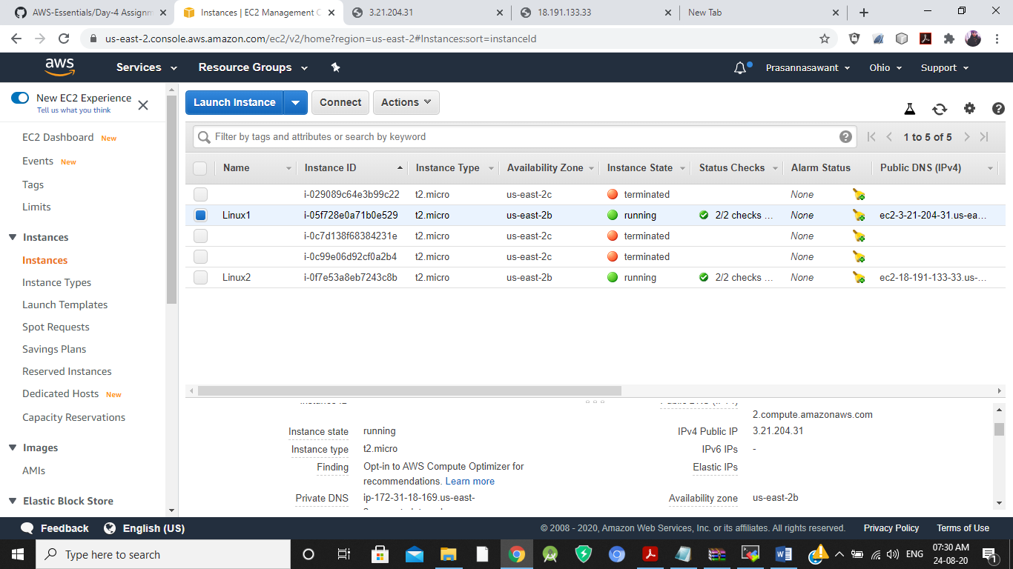

Linux1 Browser

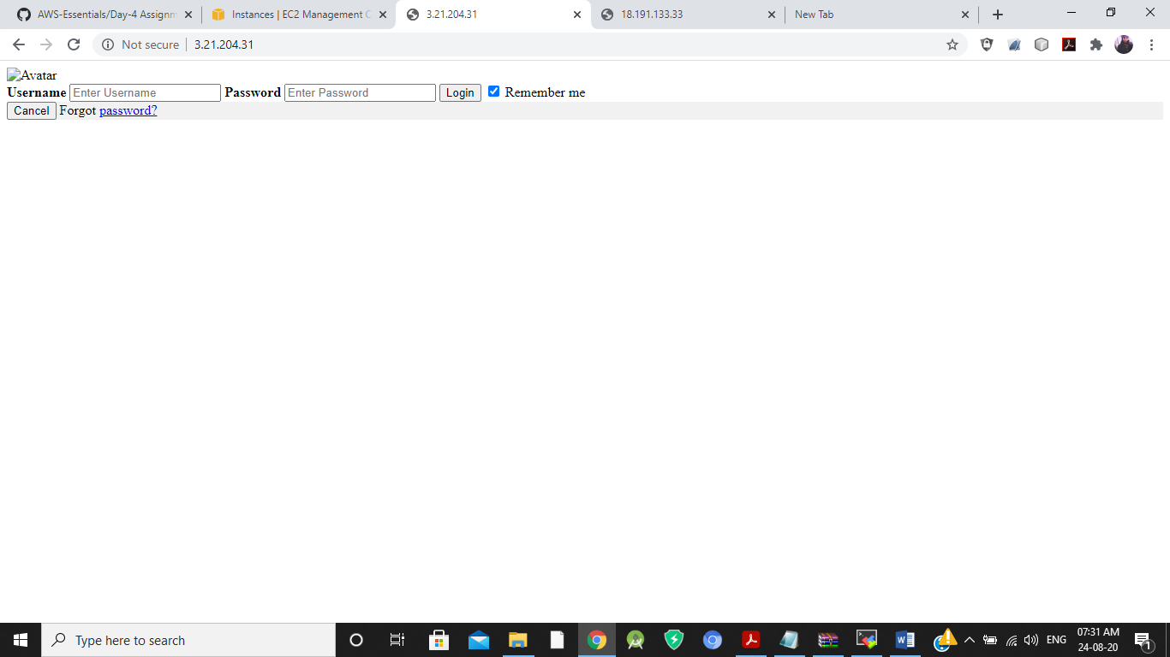

1. Linux2 Instance

Public Ip – 18.191.133.33

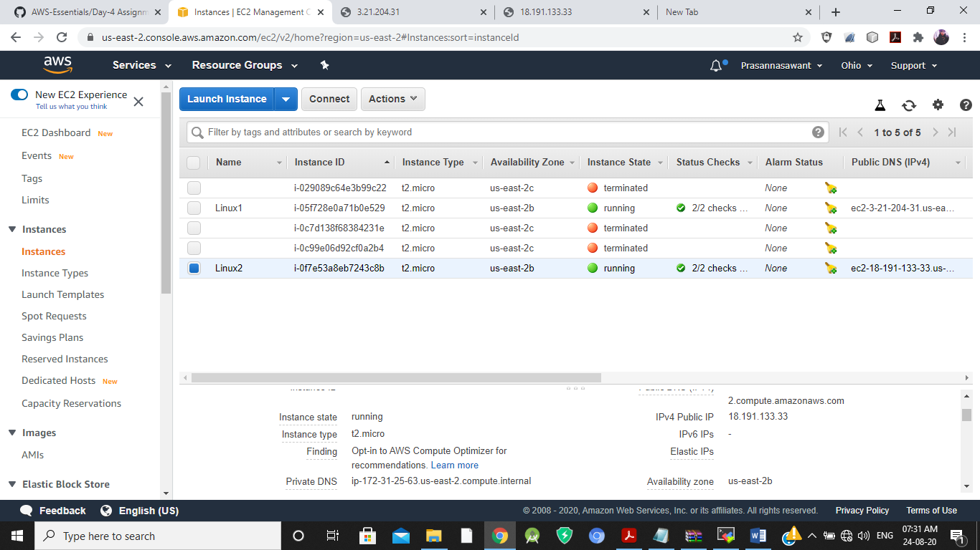

Linux2 Browser

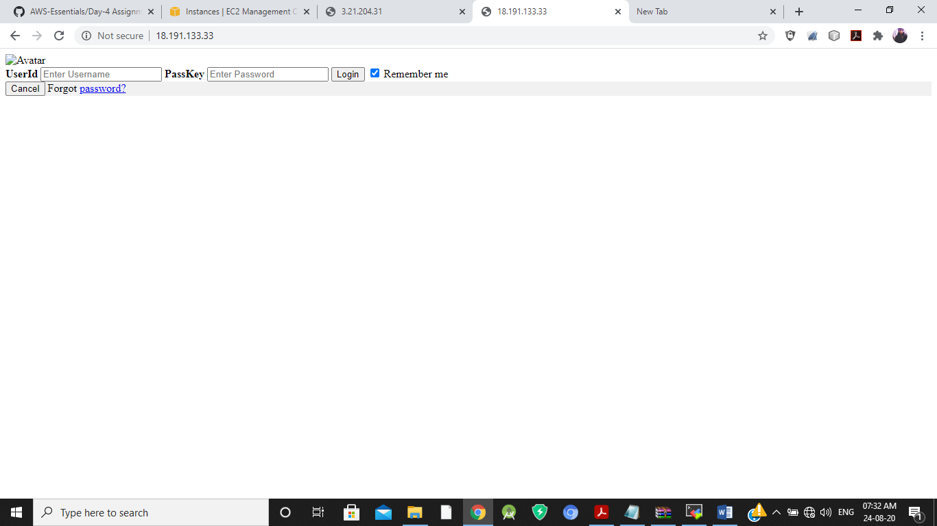

1. Load Balancer

DNS –

Letsupgradeelb-202538518.us-east-2.elb.amazonaws.com

